**Module Title**

**Internet Technologies**

**Assessment Type**

**Portfolio Coursework**

**Year**

**2024-25**

CS & DF- L3_sem-2

**Student Name: Osama Jat**

**UWE ID: 24030174**

**Assignment Submission Date: 26-6-2024**

**Week: 5**

Exercise-1

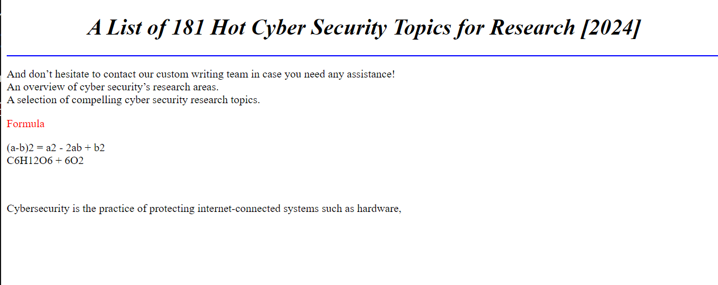

Exercise-2

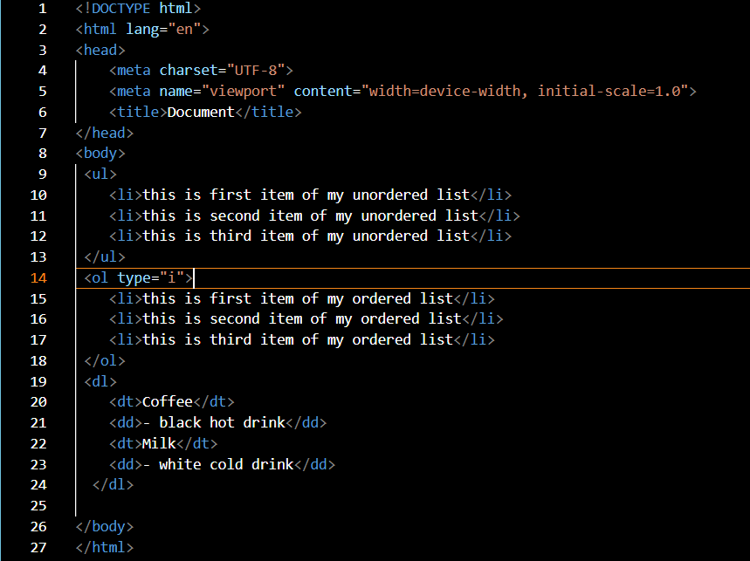

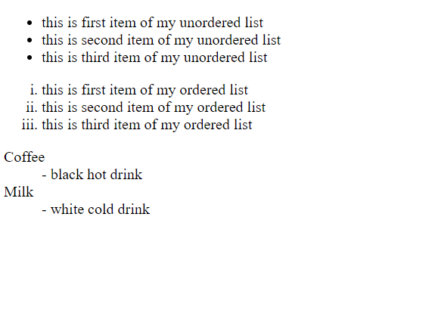

Exercise-3

